Module 3 Deploying and Managing Virtual Machines (VMs)
Creating Virtual Machines
Creating Virtual Machines (Portal)
There are many methods for deploying virtual machines. No matter what method you use, these are the basic steps for deploying a virtual machine.
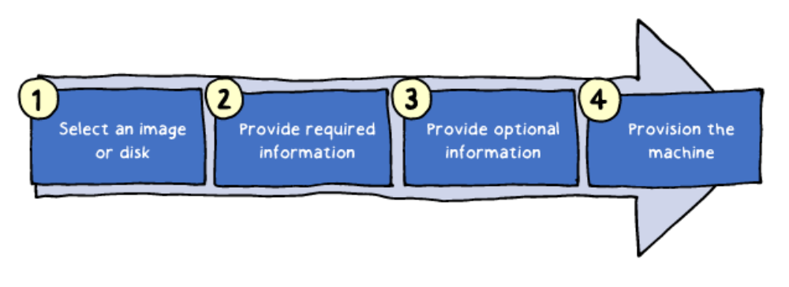
- Select an image or disk to use for your new virtual machine. The image is from the Marketplace. The disk is a VHD you have created.
- Provide required information such as host name, user name, and password for the new virtual machine.
- Provide optional information like domain membership, virtual networks, storage account, cloud service, and availability set.
- Provision the machine.

When you are creating virtual machines in the portal, one of your first decisions is the image to use. Azure supports Windows and Linux operating systems. There are server and client platforms. 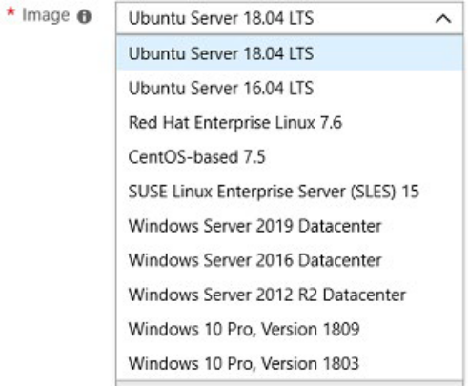

Additional images are available by searching the Marketplace.
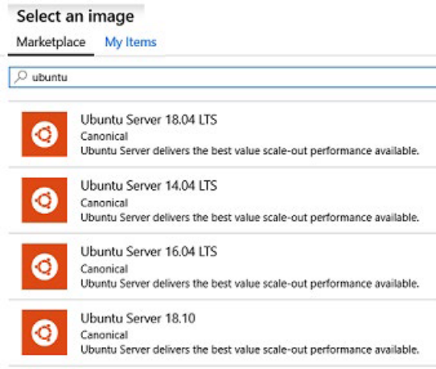

After selecting your image the portal will guide you through additional configuration informatin.
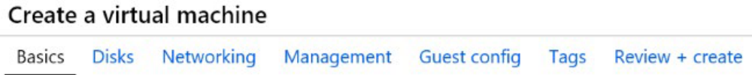
Basic - Project details, Administrator account, Inbound port rules
Disks - OS disk type, data disks
Networking - Virtual networks, load balancing
Management - Monitoring, Auto-shutdown, Backup
Guest config - Add additional configuration, agents, scripts or applications via virtual machine extensions or cloud-init.
Windows Virtual Machines
Windows Server is the operating system that bridges on-premises environments with Azure services enabling hybrid scenarios and maximizing existing investments, including:
- Unique hybrid capabilities with Azure to extend your datacenter and maximize investments, such as the Azure Hybrid Benefits.
- Advanced multi-layer security to help you elevate your security posture
- Faster innovation for applications enabling Developers and IT Pros to create new and modernize their apps, and
- Unprecedented Hyper-converged Infrastructure to evolve your datacenter infrastructure
‍
Terms of Use
Your use of the Windows Server images from Azure Marketplace Virtual Machine Gallery are provided to you for use with virtual machine instances under your Azure subscription which are governed by the Online Services Terms. These virtual machine instances are limited for use with Azure.

Latest Images
  - 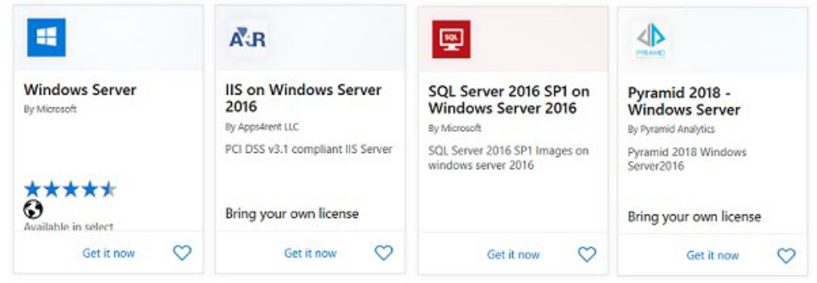

        - Windows Server 2019 is the latest Long-Term Servicing Channel (LTSC) release with five years of mainstream support + five years of extended support. Choose the image that is right for your application needs: 1) Server with Desktop Experience includes all roles including the graphical user interface (GUI), 2) Server Core omits the GUI for a smaller OS footprint, or 3) Containers option includes the Server with Desktop Experience, plus ready-made container images. Windows Server 2019 Datacenter - Server with Desktop Experience

  - Windows Server 2019 Datacenter - with Containers
  - Windows Server 2019 Datacenter - Server Core
  - Windows Server 2019 Datacenter - Server Core with Containers

Windows Server Semi-Annual Channel releases deliver new operating system capabilities at a faster pace and are based on the Server Core installation option of the Datacenter edition. A new release comes out every six months and is supported for 18 months. Check the Lifecycle Support Page for support dates and always use the latest release if possible.
✔️ There are also a large number of Windows Server 2016 and Windows Server 2012 images.
For more information, you can see:
Windows Virtual Machines Documentation - https://docs.microsoft.com/en-us/azure/virtual-machines/windows/
Demonstration: Creating Virtual Machines
https://www.youtube.com/watch?v=r-F-lAcioiI 112 Module 3 Deploying and Managing Virtual Machines (VMs)
Windows VM Connections
To manage an Azure Windows VM, you can use the same set of tools that you used to deploy it. However, you will also want to interact with an operating system (OS) running within the VM. The methods you can use to accomplish this are OS-specific and include the following options:
- Remote Desktop Protocol (RDP) allows you to establish a graphical user interface (GUI) session to an Azure VM that runs any supported version of Windows. The Azure portal automatically enables the Connect button on the Azure Windows VM blade if the VM is running and accessible via a public or private IP address, and if it accepts inbound traffic on TCP port 3389. After you click this button, the portal will automatically provision an .rdp file, which you can either open or download. Opening the file initiates an RDP connection to the corresponding VM. You will get a warning that the .rdp file is from an unknown publisher. This is expected. When connecting be sure to credentials for the virtual machine. The Azure PowerShell Get-AzRemoteDesktopFile cmdlet provides the same functionality.

  - 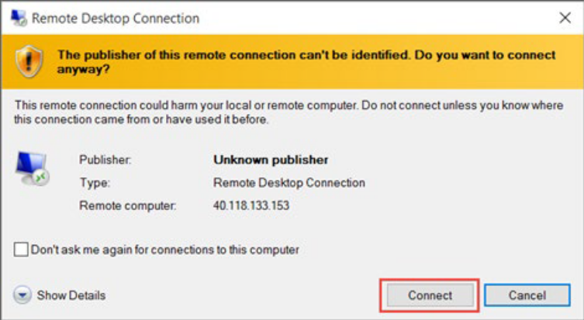
  - Windows Remote Management (WinRM) allows you to establish a command-line session to an Azure VM that runs any supported version of Windows. You can also use WinRM to run noninteractive Windows PowerShell scripts. WinRM facilitates additional session security by using certificates. You can upload a certificate that you intend to use to Azure Key Vault prior to establishing a session. The process of setting up WinRM connectivity includes the following, high-level steps: Creating a key vault.
  - Creating a self-signed certificate.
  - Uploading the certificate to the key vault.
  - Identifying the URL of the certificate uploaded to the key vault.
  - Referencing the URL in the Azure VM configuration.

WinRM uses by TCP port 5986 by default, but you can change it to a custom value. In either case, you must ensure that no network security groups are blocking inbound traffic on the port that you choose.
For more information, you can see:
Setting up WinRM access for Virtual Machines in Azure Resource Manager: https://aka.ms/ljezi1
Demonstration - Creating a VM in the Portal
In this demonstration, we will create and access a Windows virtual machine in the portal.
Create the virtual machine
- Choose Create a resource in the upper left-hand corner of the Azure portal.
‍

- In the search box above the list of Azure Marketplace resources, search for Windows Server 2016 Datacenter. After locating the image, click Create.

- In the Basics tab, under Project details, make sure the correct subscription is selected and then choose to Create new resource group. Type myResourceGroup for the name.

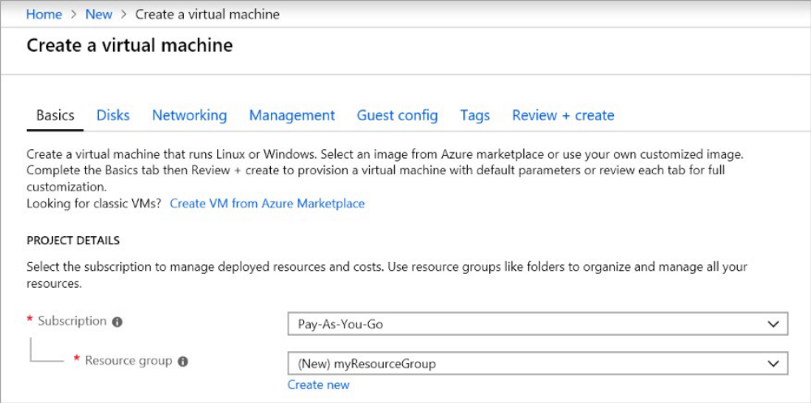
- Under Instance details, type myVM for the Virtual machine name and choose East US for your Location. Leave the other defaults.

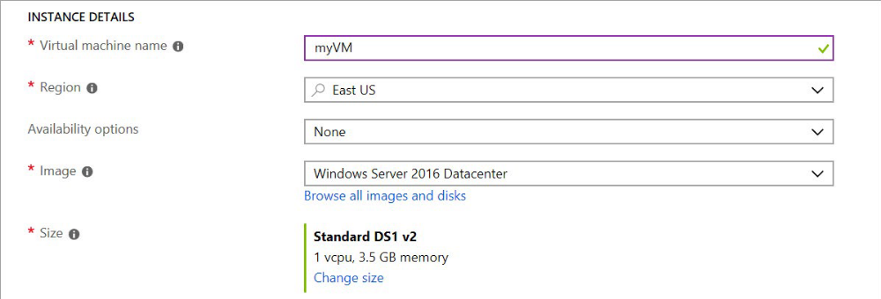

- Under Administrator account, provide a username, such as azureuser and a password. The password must be at least 12 characters long and meet the defined complexity requirements.

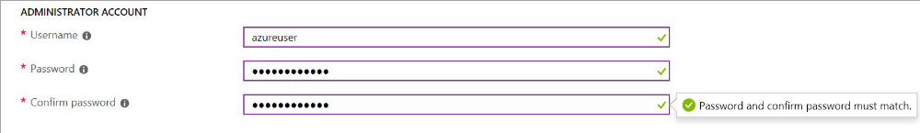

- Under Inbound port rules, choose Allow selected ports and then select RDP (3389) and HTTP from the drop-down.

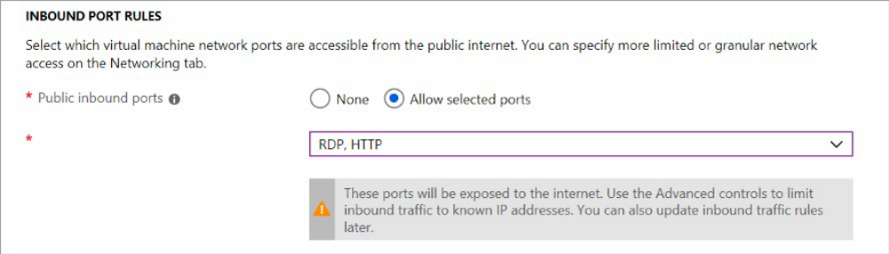

- Move to the Management tab, and under Monitoring turn Off Boot Diagnostics. This will eliminate validation errors.
- Leave the remaining defaults and then select the Review + create button at the bottom of the page. Wait for the validation, then click Create.

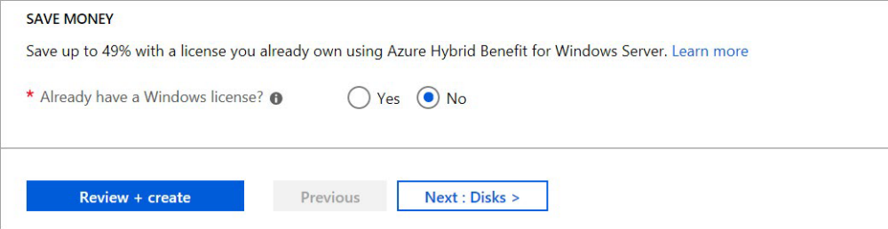

Connect to the virtual machine
Create a remote desktop connection to the virtual machine. These directions tell you how to connect to your VM from a Windows computer. On a Mac, you need to install an RDP client from the Mac App Store.
- Select the Connect button on the virtual machine properties page.
- In the Connect to virtual machine page, keep the default options to connect by DNS name over port 3389 and click Download RDP file.
- Open the downloaded RDP file and select Connect when prompted.
- In the Windows Security window, select More choices and then Use a different account. Type the username as localhost\username, enter password you created for the virtual machine, and then select OK.
- You may receive a certificate warning during the sign-in process. Select Yes or Continue to create the connection.

Install web server
To see your VM in action, install the IIS web server. Open a PowerShell prompt on the VM and run the following command:
Install-WindowsFeature -name Web-Server -IncludeManagementTools
When done, close the RDP connection to the VM.
View the IIS welcome page ‍Creating Virtual Machines 115
In the portal, select the VM and in the overview of the VM, use the Click to copy button to the right of the public IP address to copy it and paste it into a browser tab. The default IIS welcome page will open, and should look like this:

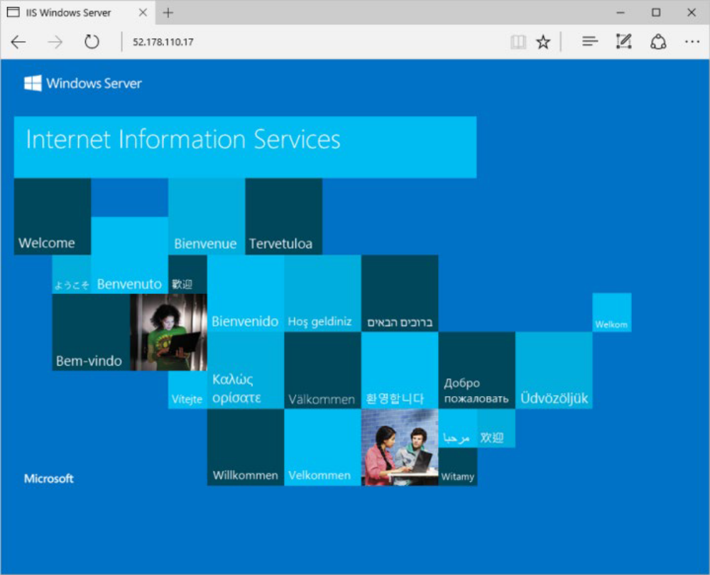

Clean up resources
✔️ When no longer needed, you can delete the resource group, virtual machine, and all related resources. To do so, select the resource group for the virtual machine, select Delete, then confirm the name of the resource group to delete.
PowerShell - Example (Part 1)
You can also create a virtual machine using PowerShell. In this example, a virtual machine is created with a name of myVM running the latest version of Windows Server 2016 Datacenter.
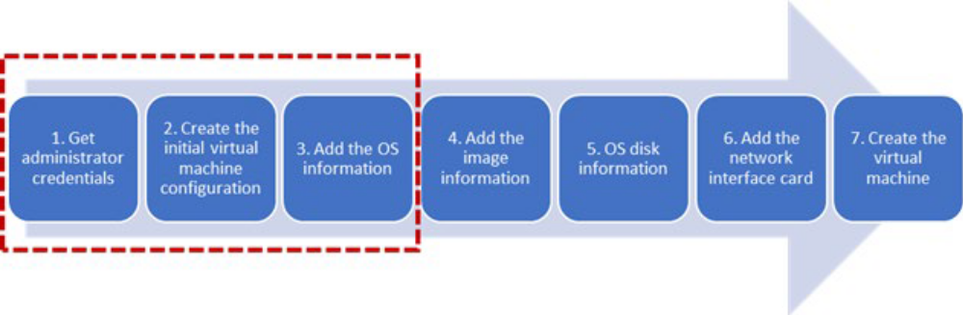

- Set the username and password needed for the administrator account on the virtual machine with Get-Credential:

$cred = Get-Credential
- Create the initial configuration for the virtual machine with New-AzVMConfig:

$vm = New-AzVMConfig -VMName myVM -VMSize Standard_D1
- Add the operating system information to the virtual machine configuration with Set-AzureRmVMOperatingSystem:

$vm = Set-AzVMOperatingSystem ` -VM $vm ` -Windows ` -ComputerName myVM ` -Credential $cred ` -ProvisionVMAgent -EnableAutoUpdate
✔️ Continues in the next topic.
PowerShell - Example (Part 2)
This continues the example on the previous page.
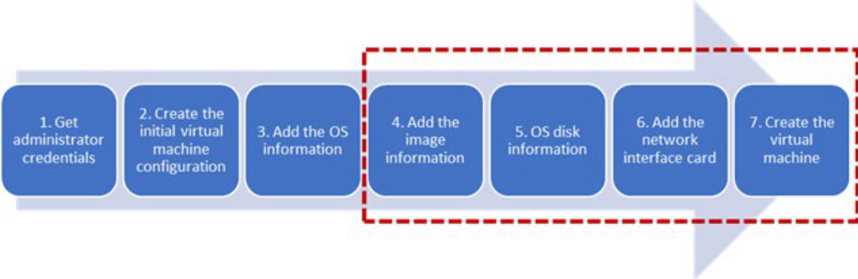
- Add the image information to the virtual machine configuration with Set-AzVMSourceImage:

$vm = Set-AzVMSourceImage ` -VM $vm ` -PublisherName MicrosoftWindowsServer ` -Offer WindowsServer ` -Skus 2016-Datacenter ` -Version latest
- Add the operating system disk settings to the virtual machine configuration with Set-AzVMOSDisk:

$vm = Set-AzVMOSDisk ` -VM $vm ` -Name myOsDisk ` -DiskSizeInGB 128 ` -CreateOption FromImage ` -Caching ReadWrite
- Add the network interface card that you previously created to the virtual machine configuration with Add-AzureRmVMNetworkInterface:

$vm = Add-AzVMNetworkInterface -VM $vm -Id $nic.Id
- Create the virtual machine with New-AzVM.

New-AzVM -ResourceGroupName myResourceGroupVM -Location EastUS -VM $vm

Demonstration - Creating a Virtual Machine with PowerShell
In this demonstration, we will create a virtual machine using PowerShell.
Create the virtual machine
Note: You can use the Cloud Shell or a local version of PowerShell.
Note: There are many ways to create a virtual machine with PowerShell. This example is different from the one explained in the topic slides.
- Launch the Cloud Shell.
- Run this code:

# create a resource group New-AzResourceGroup -Name myResourceGroup -Location EastUS # create the virtual machine # when prompted, provide a username and password to be used as the logon credentials for the VM New-AzVm ` -ResourceGroupName "myResourceGroup" ` -Name "myVM" ` -Location "East US" ` -VirtualNetworkName "myVnet" ` -SubnetName "mySubnet" ` -SecurityGroupName "myNetworkSecurityGroup" ` -PublicIpAddressName "myPublicIpAddress" ` -OpenPorts 80,3389
Verify the machine creation in the portal
- Access the portal and view your virtual machines.
- Verify myVM was created.
- Review the VM settings.
- Notice this is a Windows machine in a new VNet and subnet.
- Notice the command started the machine.
- At this point you could use either the portal or PowerShell to make changes.

Connect to the virtual machine
- Retrieve the public IP address of the machine.

Get-AzPublicIpAddress -ResourceGroupName "myResourceGroup" | Select "IpAddress"
- Create an RDP session from your local machine. Replace the IP address with the public IP address of your VM. This command runs from a cmd window.
118 Module 3 Deploying and Managing Virtual Machines (VMs)
mstsc /v:publicIpAddress
- When prompted, provide your login credentials for the machine. Be sure to Use a different account. Type the username as localhost\username, enter password you created for the virtual machine, and then select OK. You may receive a certificate warning during the sign-in process. Select Yes or Continue to create the connection
- When done, close the RDP connection to the VM.
- Clean up your resources. This will take a few minutes and remove the resource group and virtual machine.

Remove-AzResourceGroup -Name myResourceGroup
Linux Virtual Machines
Azure supports many Linux distributions and versions including CentOS by OpenLogic, Core OS, Debian, Oracle Linux, Red Hat Enterprise Linux, and Ubuntu.

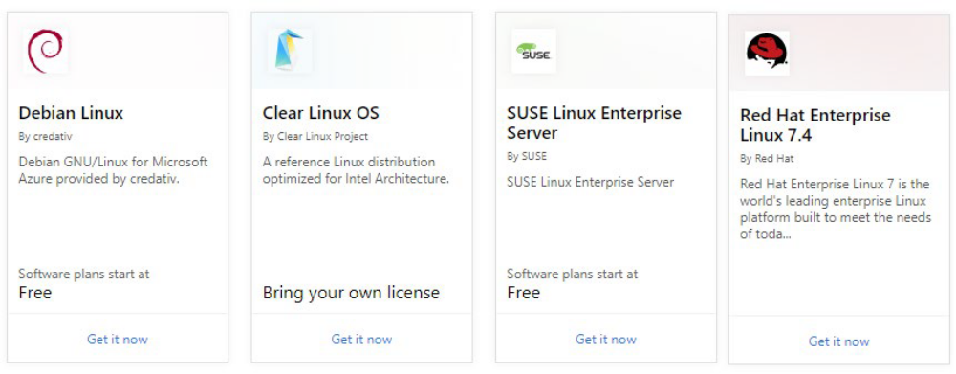
Here are a few things to know about the Linux distributions.
- There are hundreds of Linux images in the Azure Marketplace.
- Linux has the same deployment options as for Windows virtual machines: PowerShell (Resource Manager), Portal, and Command Line Interface. You can manage your Linux virtual machines with a host of popular open-source DevOps tools such as Puppet, and Chef.

✔️ Take a few minutes to look through the Marketplace at the Linux distributions. Are there any you are interested in?
For more information, you can see:
Linux virtual machines (Documentation) - https://docs.microsoft.com/en-us/azure/virtual-machines/ linux/
Linux VM Connections
When you create a Linux VM, you can decide to authenticate with an SSH public key or Password. ‍Creating Virtual Machines 119
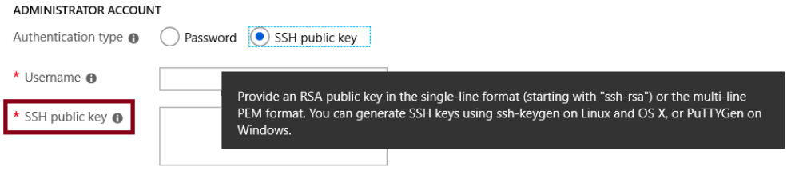
What is SSH?
SSH is an encrypted connection protocol that allows secure sign-ins over unsecured connections. SSH is the default connection protocol for Linux VMs hosted in Azure. Although SSH itself provides an encrypted connection, using passwords with SSH connections still leaves the VM vulnerable to brute-force attacks or guessing of passwords. A more secure and preferred method of connecting to a VM using SSH is by using a public-private key pair, also known as SSH keys.
- The public key is placed on your Linux VM, or any other service that you wish to use with public-key cryptography.
- The private key remains on your local system. Protect this private key. Do not share it.

When you use an SSH client to connect to your Linux VM (which has the public key), the remote VM tests the client to make sure it possesses the private key. If the client has the private key, it's granted access to the VM.
Depending on your organization's security policies, you can reuse a single public-private key pair to access multiple Azure VMs and services. You do not need a separate pair of keys for each VM or service you wish to access.
Your public key can be shared with anyone, but only you (or your local security infrastructure) should possess your private key.
✔️ Azure currently requires at least a 2048-bit key length and the SSH-RSA format for public and private keys.
Virtual Machine Sizes (Linux and Windows)
This section describes the available sizes and options for the Azure virtual machines you can use to run your Linux and Windows apps and workloads. It also provides deployment considerations to be aware of when you're planning to use these resources.
Sizes for Windows virtual machines in Azure
Type | Sizes | Description
General purpose | B, Dsv3, Dv3, Dasv4, Dav4, DSv2, Dv2, Av2, DC | Balanced CPU-to-memory ratio. Ideal for testing and development, small to medium databases, and low to medium traffic web servers.
Compute optimized | Fsv2 | High CPU-to-memory ratio. Good for medium traffic web servers, network appliances, batch processes, and application servers.
Type | Sizes | Description
Memory optimized | Esv3, Ev3, Easv4, Eav4, Mv2, M, DSv2, Dv2 | High memory-to-CPU ratio. Great for relational database servers, medium to large caches, and in-memory analytics.
Storage optimized | Lsv2 | High disk throughput and IO ideal for Big Data, SQL, NoSQL databases, data warehousing and large transactional databases.
GPU | NC, NCv2, NCv3, ND, NDv2 (Preview), NV, NVv3, NVv4 (Preview) | Specialized virtual machines targeted for heavy graphic rendering and video editing, as well as model training and inferencing (ND) with deep learning. Available with single or multiple GPUs.
High performance compute | HB, HC, H | Our fastest and most powerful CPU virtual machines with optional high-throughput network interfaces (RDMA).

Sizes for Linux virtual machines in Azure
Type | Sizes | Description
General purpose | B, Dsv3, Dv3, Dasv4, Dav4, DSv2, Dv2, Av2, DC | Balanced CPU-to-memory ratio. Ideal for testing and development, small to medium databases, and low to medium traffic web servers.
Compute optimized | Fsv2 | High CPU-to-memory ratio. Good for medium traffic web servers, network appliances, batch processes, and application servers.
Memory optimized | Esv3, Ev3, Easv4, Eav4, Mv2, M, DSv2, Dv2 | High memory-to-CPU ratio. Great for relational database servers, medium to large caches, and in-memory analytics.
Storage optimized | Lsv2 | High disk throughput and IO ideal for Big Data, SQL, NoSQL databases, data warehousing and large transactional databases
Type | Sizes | Description
GPU | NC, NCv2, NCv3, ND, NDv2 (Preview), NV, NVv3 | Specialized virtual machines targeted for heavy graphic rendering and video editing, as well as model training and inferencing (ND) with deep learning. Available with single or multiple GPUs.
High performance compute | HB, HC, H | Our fastest and most powerful CPU virtual machines with optional high-

Azure Dedicated Host
Azure Dedicated Host is a service that provides physical servers - able to host one or more virtual machines - dedicated to one Azure subscription. Dedicated hosts are the same physical servers used in our data centers, provided as a resource. You can provision dedicated hosts within a region, availability zone, and fault domain. Then, you can place VMs directly into your provisioned hosts, in whatever configuration best meets your needs.
Limitations
- Virtual machine scale sets are not currently supported on dedicated hosts.
- The following VM series are supported: DSv3 and ESv3.

Benefits
Reserving the entire host provides the following benefits:
- Hardware isolation at the physical server level. No other VMs will be placed on your hosts. Dedicated hosts are deployed in the same data centers and share the same network and underlying storage infrastructure as other, non-isolated hosts.
- Control over maintenance events initiated by the Azure platform. While the majority of maintenance events have little to no impact on your virtual machines, there are some sensitive workloads where each second of pause can have an impact. With dedicated hosts, you can opt-in to a maintenance window to reduce the impact to your service.
- With the Azure hybrid benefit, you can bring your own licenses for Windows and SQL to Azure. Using the hybrid benefits provides you with additional benefits. For more information, see Azure Hybrid Benefit1
- 1 https://azure.microsoft.com/pricing/hybrid-benefit/.

Groups, hosts, and VMs
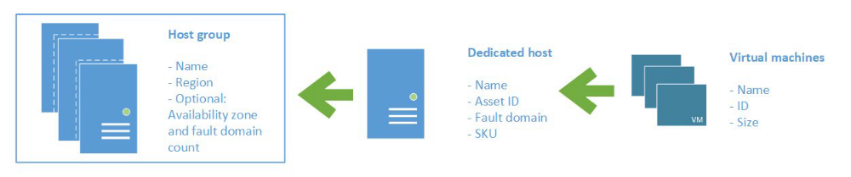
A host group is a resource that represents a collection of dedicated hosts. You create a host group in a region and an availability zone, and add hosts to it.
A host is a resource, mapped to a physical server in an Azure data center. The physical server is allocated when the host is created. A host is created within a host group. A host has a SKU describing which VM sizes can be created. Each host can host multiple VMs, of different sizes, as long as they are from the same size series.
When creating a VM in Azure, you can select which dedicated host to use for your VM. You have full control as to which VMs are placed on your hosts.
Demonstration - Connect to Linux Virtual Machines
In this demonstration, we will create a Linux machine and access the machine with SSL.
Note: Ensure port 22 is open for the connection to work.
Create the SSH Keys
- Download the PuTTY tool. This will include PuTTYgen - https://putty.org/.
- Once installed, locate and open the PuTTYgen program.
- In the Parameters option group choose RSA.
- Click the Generate button.
- Move your mouse around the blank area in the window to generate some randomness.
- Copy the text of the Public key for pasting into authorized keys file.
- Optionally you can specify a Key passphrase and then Confirm passphrase. You will be prompted for the passphrase when you authenticate to the VM with your private SSH key. Without a passphrase, if someone obtains your private key, they can sign in to any VM or service that uses that key. We recommend you create a passphrase. However, if you forget the passphrase, there is no way to recover it.
- Click Save private key.
- Choose a location and filename and click Save. You will need this file to access the VM.

Create the Linux machine and assign the public SSH key
- In the portal create a Linux machine of your choice.
- Choose SSH Public Key for the Authentication type (instead of Password ).
- Provide a Username.
- Paste the public SSH key from PuTTY into the SSH public key text area. Ensure the key validates with a checkmark.
- Create the VM. Wait for it to deploy.
- Access the running VM.
- From the Overview blade, click Connect.
- Make a note of your login information including user and public IP address.

Access the server using SSH
- Open the PuTTY tool.

- Enter username@publicIpAddress where username is the value you assigned when creating the VM and publicIpAddress is the value you obtained from the Azure portal.
- Specify 22 for the Port.
- Choose SSH in the Connection Type option group.
- Navigate to SSH in the Category panel, then click Auth.
- Click the Browse button next to Private key file for authentication.
- Navigate to the private key file saved when you generated the SSH keys and click Open.
- From the main PuTTY screen click Open.
- You will now be connected to your server command line.

Backup and Restore
Azure Site Recovery
You can use Azure Site Recovery to replicate on-premises physical or virtual machines running Windows or Linux. Azure Site Recovery includes support for both Hyper-V and VMware virtual machines. You can replicate data from your on-premises datacenter to Azure or to a secondary site. Orchestration is built in with Azure Site Recovery, which means that the management of replication, failover, and recovery is included. For example, should a virtual machine or service fail in your datacenter, you can use Azure Site Recovery to failover to the replicated resource in either Azure or your secondary site.

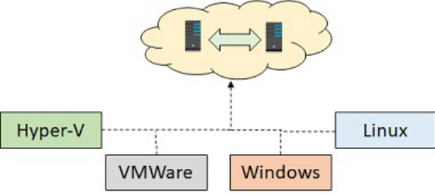

Azure Site Recovery works in the following three scenarios:
- Hyper-V Virtual Machine Replication. When Virtual Machine Manager (VMM) is used to manage Hyper-V virtual machines, you can use Azure Site Recovery to replicate them to Azure or to a secondary datacenter. If you do not use VMM to manage your virtual machines, you can use Azure Site Recovery to replicate them to Azure only.
- VMware Virtual Machine Replication. You can perform the replication of virtual machines by VMware to a secondary site that is also running VMware. You also can replicate to Azure.
- Physical Windows and Linux machines. You can replicate physical machines running either Windows or Linux to a secondary site or to Azure.

Azure Site Recovery Benefits
A migration to the cloud can result in significant business benefits. Here are some reasons to use Azure Site Recovery.
- Eliminate the need for disaster recovery sites. Your environment can be protected by automating the replication of the virtual machines based on policies that you set and control. Site Recovery is heterogeneous and can protect Hyper-V, VMware, and physical servers.
- Reduce infrastructure costs. Lower your on-premises infrastructure costs by using Azure as a secondary site for conducting business during outages. Or, eliminate datacenter costs altogether by moving to Azure and setting up disaster recovery between Azure regions. You can pre-assess network, storage, and compute resources needed to replicate applications from on-premises to Azure—and pay only for compute and storage resources needed to run apps in Azure during outages.
- Automatically replicate to Azure. Automate the orderly recovery of services in the event of a site outage at the primary datacenter. Automate the orderly recovery of services in the event of a site outage at the primary datacenter.
- Safeguard against outages of complex workloads. Protect applications in SQL Server, SharePoint, SAP, and Oracle.
- Extend or boost capacity. Applications can be Migrated to Azure with just a few clicks or burst to Azure temporarily when you encounter a surge in demand.

- Continuous health monitoring. Site Recovery monitors the state of your protected instances continuously and remotely from Azure. When replicating between two sites you control, your virtual machines’ data and replication remains on your networks. All communication with Azure is encrypted.

✔️ Are you considering using Azure Site Recovery and are you interested in any of these specific features? Which one is most important to you?
For more information, you can see:
Azure Site Recovery documentation - https://azure.microsoft.com/en-us/services/site-recovery/
Virtual Machine Data Protection
You can protect your data by taking backups at regular intervals. There are several backup options available for VMs, depending on your use-case.

Azure Backup
For backing up Azure VMs running production workloads, use Azure Backup. Azure Backup supports application-consistent backups for both Windows and Linux VMs. Azure Backup creates recovery points that are stored in geo-redundant recovery vaults. When you restore from a recovery point, you can restore the whole VM or just specific files. The topics in this lesson will focus on Azure Backup.
Azure Site Recovery
Azure Site Recovery protects your VMs from a major disaster scenario when a whole region experiences an outage due to major natural disaster or widespread service interruption. You can configure Azure Site Recovery for your VMs so that you can recover your application with a single click in matter of minutes. You can replicate to an Azure region of your choice.
Managed disk snapshots
In development and test environments, snapshots provide a quick and simple option for backing up VMs that use Managed Disks. A managed disk snapshot is a read-only full copy of a managed disk that is stored as a standard managed disk by default. With snapshots, you can back up your managed disks at any point in time. These snapshots exist independent of the source disk and can be used to create new managed disks. They are billed based on the used size. For example, if you create a snapshot of a managed disk with provisioned capacity of 64 GiB and actual used data size of 10 GiB, that snapshot is billed only for the used data size of 10 GiB.
Images
Managed disks also support creating a managed custom image. You can create an image from your custom VHD in a storage account or directly from a generalized (sysprepped) VM. This process captures a single image. This image contains all managed disks associated with a VM, including both the OS and data disks. This managed custom image enables creating hundreds of VMs using your custom image without the need to copy or manage any storage accounts.
Images versus snapshots

It's important to understand the difference between images and snapshots. With managed disks, you can take an image of a generalized VM that has been deallocated. This image includes all of the disks attached to the VM. You can use this image to create a VM, and it includes all of the disks.
- A snapshot is a copy of a disk at the point in time the snapshot is taken. It applies only to one disk. If you have a VM that has one disk (the OS disk), you can take a snapshot or an image of it and create a VM from either the snapshot or the image.
- A snapshot doesn't have awareness of any disk except the one it contains. This makes it problematic to use in scenarios that require the coordination of multiple disks, such as striping. Snapshots would need to be able to coordinate with each other and this is currently not supported.

✔️ Have you tried any of these backup methods? Do you have a backup plan?
.
Workload Protection Needs
There are several methods for backing up virtual machines.
- Enable backup for individual Azure VMs. When you enable backup, Azure Backup installs an extension to the Azure VM agent that's running on the VM. The agent backs up the entire VM.
- Run the MARS agent on an Azure VM. This is useful if you want to back up individual files and folders on the VM.
- Back up an Azure VM to a System Center Data Protection Manager (DPM) server or Microsoft Azure Backup Server (MABS) running in Azure. Then back up the DPM server/MABS to a vault using Azure Backup.

Often those that are new to deploying workloads in a public cloud do not consider how they will protect the workload once it is hosted there. This is, of course, a critical requirement for business continuity. Document how the workload is being protected today, including how often the workload is backed up, what types of backups are accomplished, and whether disaster recovery protection is in place for the workload. Options for workload protection include:
- Extending on-premises data protection solutions into Azure. In many cases, an organization can extend their backup strategy into Azure by choosing from many of the backup solutions available

today in the Azure Marketplace.
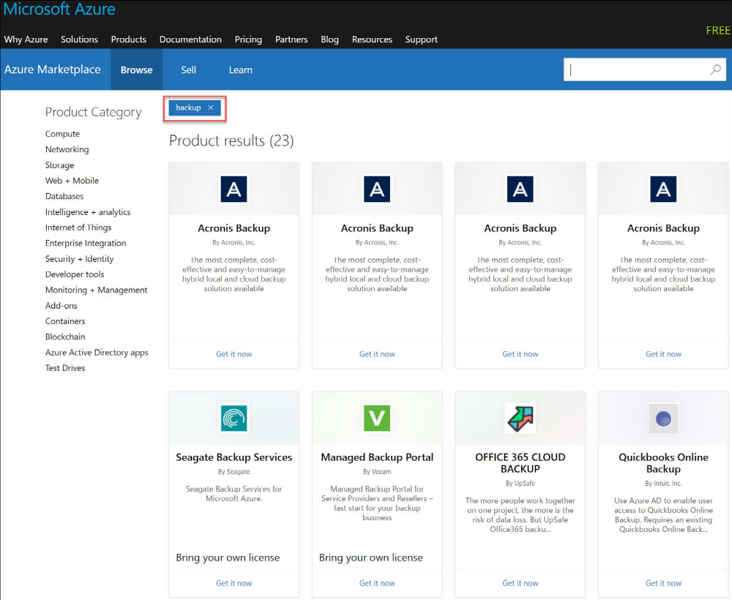

Using native features in Azure to enable data protection, such as Azure Backup. Azure Backup is a native data protection service in Azure that allows for the protection of on-premises and Azure workloads.
Azure to Azure Architecture
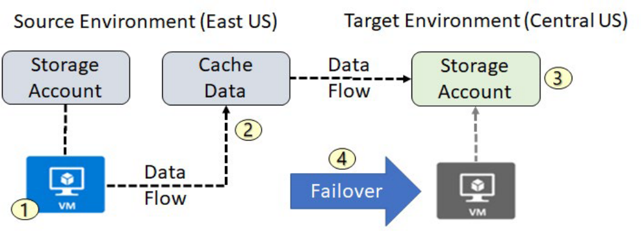

When you enable replication for an Azure VM, the following happens:
- The Site Recovery Mobility service extension is automatically installed on the VM. The extension registers the VM with Site Recovery. Continuous replication begins for the VM. Disk writes are immediately transferred to the cache storage account in the source location.
- Site Recovery processes the data in the cache, and sends it to the target storage account, or to the replica managed disks.
- After the data is processed, crash-consistent recovery points are generated every five minutes. App-consistent recovery points are generated according to the setting specified in the replication policy.
- When you initiate a failover, the VMs are created in the target resource group, target virtual network, target subnet, and in the target availability set. During a failover, you can use any recovery point.

Recovery Services Vault VM Backup Options
Recovery Services vault is a storage entity in Azure that houses data. The data is typically copies of data, or configuration information for virtual machines (VMs), workloads, servers, or workstations. You can use Recovery Services vaults to hold backup data for various Azure services such as IaaS VMs (Linux or Windows) and Azure SQL databases. Recovery Services vaults support System Center DPM, Windows Server, Azure Backup Server, and more. Recovery Services vaults make it easy to organize your backup data, while minimizing management overhead.
- The Recovery Services vault can be used to backup Azure virtual machines.

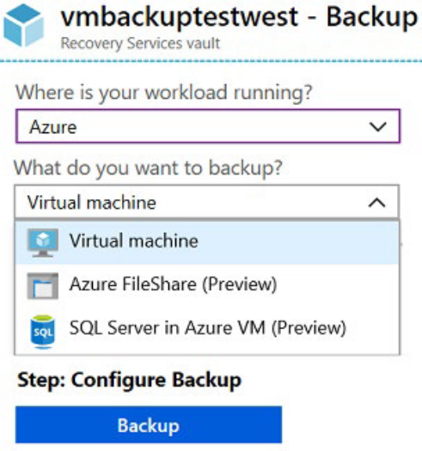

The
Recovery Services vault can be used to backup on-premises virtual machines including: Hyper-V, VmWare, System State, and Bare Metal Recovery.

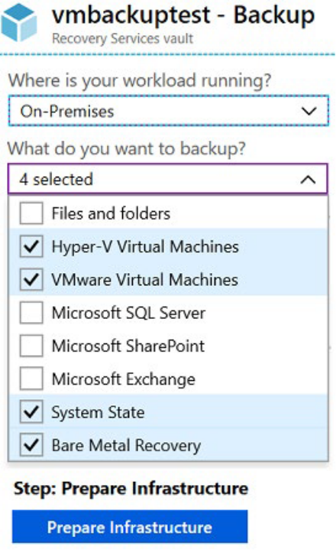

Implementing VM Backups
Backing up Azure virtual machines using Azure Backup is easy and follows a simple process.
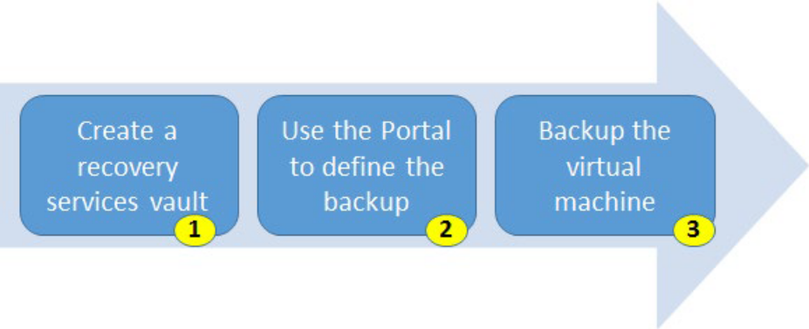

- Create a recovery services vault. To back up your files and folders, you need to create a Recovery Services vault in the region where you want to store the data. You also need to determine how you want your storage replicated, either geo-redundant (default) or locally redundant. By default, your vault has geo-redundant storage. If you are using Azure as a primary backup storage endpoint, use the default geo-redundant storage. If you are using Azure as a non-primary backup storage endpoint, then choose locally redundant storage, which will reduce the cost of storing data in Azure.
- Use the Portal to define the backup. Protect your data by taking snapshots of your data at defined intervals. These snapshots are known as recovery points, and they are stored in recovery services vaults. If or when it is necessary to repair or rebuild a VM, you can restore the VM from any of the saved recovery points. A backup policy defines a matrix of when the data snapshots are taken, and how long those snapshots are retained. When defining a policy for backing up a VM, you can trigger a backup job once a day.
- Backup the virtual machine. The Azure VM Agent must be installed on the Azure virtual machine for the Backup extension to work. However, if your VM was created from the Azure gallery, then the VM Agent is already present on the virtual machine. VMs that are migrated from on-premises data centers would not have the VM Agent installed. In such a case, the VM Agent needs to be installed.
For more information, you can see:
Plan your VM backup infrastructure in Azure - https://docs.microsoft.com/en-us/azure/backup/ backup-azure-vms-introduction
Implementing VM Restore
Once your virtual machine snapshots are safely in the recovery services vault it is easy to recover them.

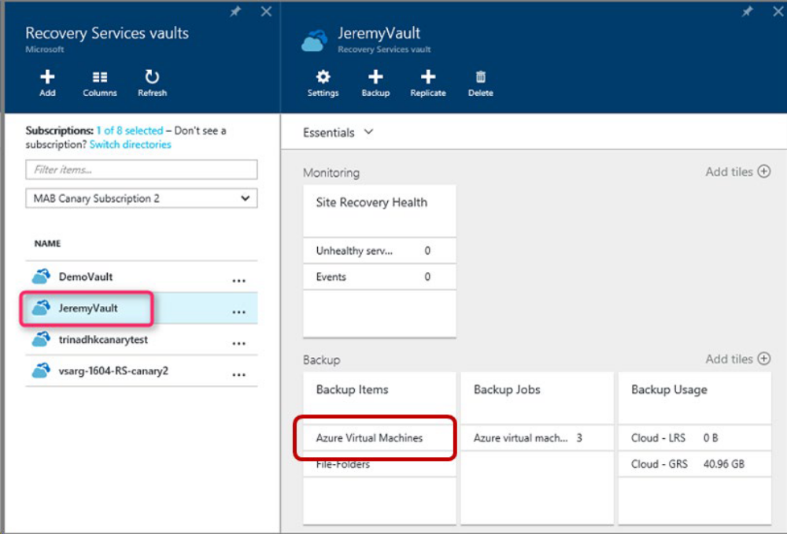
Once you trigger the restore operation, the Backup service creates a job for tracking the restore operation. The Backup service also creates and temporarily displays notifications, so you monitor how the backup is proceeding.
Azure Backup Server
Another method of backing up virtual machines is using a Data Protection Manager (DPM) or Microsoft Azure Backup Server (MABS) server. This method can be used for specialized workloads, virtual machines, or files, folders, and volumes. Specialized workloads can include SharePoint, Exchange, and SQL Server.
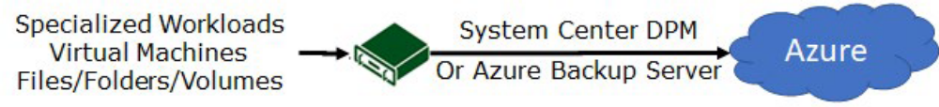

Advantages
The advantages of backing up machines and apps to MABS/DPM storage, and then backing up DPM/ MABS storage to a vault are as follows:
- Backing up to MABS/DPM provides app-aware backups optimized for common apps such as SQL Server, Exchange, and SharePoint, in additional to file/folder/volume backups, and machine state backups (bare-metal, system state).
MCT USE ONLY. STUDENT USE PROHIBITED ‍Backup and Restore 131

- For on-premises machines, you don't need to install the MARS agent on each machine you want to back up. Each machine runs the DPM/MABS protection agent, and the MARS agent runs on the MABS/DPM only.
- You have more flexibility and granular scheduling options for running backups.
- You can manage backups for multiple machines that you gather into protection groups in a single console. This is particularly useful when apps are tiered over multiple machines and you want to back them up together.

Backup steps
- Install the DPM or MABS protection agent on machines you want to protect. You then add the machines to a DPM protection group.
- To protect on-premises machines, the DPM or MABS server must be located on-premises.
- To protect Azure VMs, the MABS server must be located in Azure, running as an Azure VM.
- With DPM/MABS, you can protect backup volumes, shares, files, and folders. You can also protect a machine's system state (bare metal), and you can protect specific apps with app-aware backup settings.
- When you set up protection for a machine or app in DPM/MABS, you select to back up to the MABS/ DPM local disk for short-term storage and to Azure for online protection. You also specify when the backup to local DPM/MABS storage should run and when the online backup to Azure should run.
- The disk of the protected workload is backed up to the local MABS/DPM disks, according to the schedule you specified.
- The DPM/MABS disks are backed up to the vault by the MARS agent that's running on the DPM/ MABS server.

Backup Component Comparison
This table summarizes the Azure Backup (MARS) agent and the Azure Backup Server usage cases.
Component | Benefits | Limits | What is protected? | Where are backups stored?
Azure Backup (MARS) agent | Backup files and folders on physical or virtual Windows OS; no separate backup server required | Backup 3x per day; not application aware; file, folder, and volume-level restore only; no support for Linux | Files and folders | Recovery services vault

Component | Benefits | Limits | What is protected? | Where are backups stored?
Azure Backup Server | App aware snapshots; full flex for when to backups; recovery granularity; linux support on Hyper-V and VMware VMs; backup and restore VMware VMs, doesn't require a System Center license | Cannot backup Oracle workloads; always requires live Azure subscription; no support for tape backup | Files, folders, volumes, VMs, applications, and workloads | Recovery services vault, locally attached disk
Virtual Machine Extensions
Virtual Machine Extensions
Creating and maintaining virtual machines can be a lot of work, and much of it is repetitive, requiring the same steps each time. Fortunately, there are several ways to automate the tasks of creating, maintaining, and removing virtual machines. One way is to use a virtual machine extension.
Azure virtual machine extensions are small applications that provide post-deployment configuration and automation tasks on Azure VMs. For example, if a virtual machine requires software installation, anti-virus protection, or a configuration script inside, a VM extension can be used. Extensions are all about managing your virtual machines.
Azure VM extensions can be:
- Managed with Azure CLI, PowerShell, Azure Resource Manager templates, and the Azure portal.
- Bundled with a new VM deployment or run against any existing system. For example, they can be part of a larger deployment, configuring applications on VM provision, or run against any supported extension operated systems post deployment.

There are different extensions for Windows and Linux machines and a large choice of first and third-party extensions.
✔️

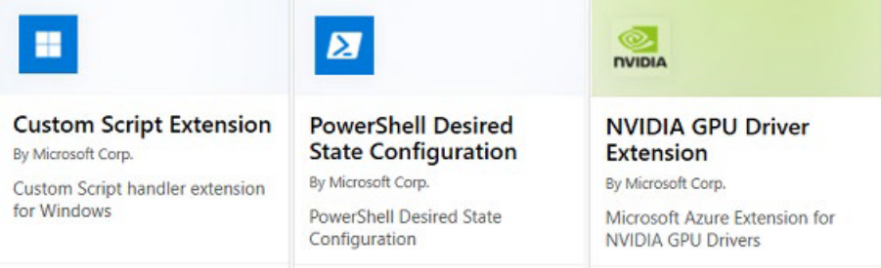
In this lesson we will focus on two extensions: Custom Script Extensions and Desired State Configuration. Both tools are based on PowerShell.
For more information, you can see:
Virtual machine extensions and features for Windows - https://docs.microsoft.com/en-us/azure/ virtual-machines/extensions/features-windows?toc=%2Fazure%2Fvirtual-machines%2Fwindows%2Ftoc.json
Virtual machine extensions and features for Linux - https://docs.microsoft.com/en-us/azure/virtual-machines/extensions/features-linux
Custom Script Extensions
Custom Script Extension (CSE) can be used to automatically launch and execute virtual machine customization tasks post configuration. Your script extension may perform very simple tasks such as stopping the virtual machine or installing a software component. However, the script could be more complex and perform a series of tasks.
Implementation
You can install the CSE from the Azure portal by accessing the virtual machines Extensions blade. Once the CSE resource is created, you will provide a PowerShell script file. Your script file will include the PowerShell commands you want to execute on the virtual machine. Optionally, you can pass in arguments, such as param1, param2. Once the file is uploaded it executes immediately.
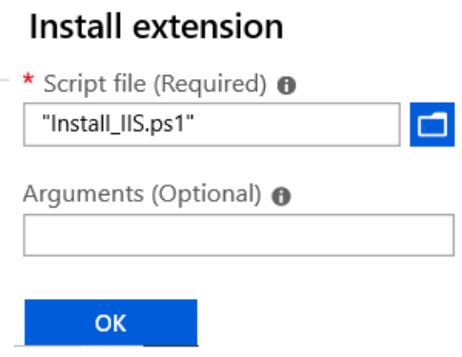
You could also use the PowerShell Set-AzVmCustomScriptExtension command. You need to upload the script file to a blob container and provide the URI in the command like this:
Set-AzVmCustomScriptExtension -FileUri https://scriptstore.blob.core.windows.net/scripts/Install_IIS.ps1 -Run "PowerShell.exe" -VmName vmName -ResourceGroupName resourceGroup -Location "location"
Things to consider
- Timeout. Custom Script extensions have 90 minutes to run. If your deployment exceeds this time, it is marked as a timeout. Keep this in mind when designing your script. And, of course, your virtual machine must be running to perform the tasks.
- Dependencies. If your extension requires networking or storage access, make sure that content is available.
- Failure events. Be sure to account for any errors that might occur when running your script. For example, running out of disk space, or security and access restrictions. What will the script do if there is an error?
- Sensitive data. Your extension may need sensitive information such as credentials, storage account names, and storage account access keys. How will you protect/encrypt this information?

✔️ Can you think of any custom script extensions that you might want to create?
Desired State Configuration
Desired State Configuration (DSC) is a management platform in Windows PowerShell that enables deploying and managing configuration data for software services and managing the environment in which these services run. DSC provides a set of Windows PowerShell language extensions, Windows PowerShell cmdlets, and resources that you can use to declaratively specify how you want your software environment to be configured. It also provides a means to maintain and manage existing configurations.
DSC centers around creating configurations. A configuration is an easy-to-read script that describes an environment made up of computers (nodes) with specific characteristics. These characteristics can be as simple as ensuring a specific Windows feature is enabled or as complex as deploying SharePoint. Use DSC when the CSE will not work for your application.
In this example we are installing IIS on the localhost. The configuration will saved as a .ps1 file.

configuration IISInstall { Node “localhost” { WindowsFeature IIS {
Ensure = “Present” Name = “Web-Server” } } }

Notice the DSC script consists of the following:
- The Configuration block. This is the outermost script block. You define it by using the Configuration keyword and providing a name. In this case, the name of the configuration is IISInstall.
- One or more Node blocks. These define the nodes (computers or VMs) that you are configuring. In the above configuration, there is one Node block that targets a computer named “localhost”.
- One or more resource blocks. This is where the configuration sets the properties for the resources that it is configuring. In this case, there is one resource block that uses the WindowsFeature resource2
- 2 https://docs.microsoft.com/en-us/powershell/scripting/dsc/reference/resources/windows/windowsfeatureresource?view=powershell-7. WindowsFeature indicates the name (Web-Server) of the role or feature that you want to ensure is added or removed. Ensure indicates if the role or feature is added. Your choices are Present and Absent.

✔️ The Windows PowerShell DSC comes with a set of built-in configuration resources. For example, File Resource, Log Resource, and User Resource. Use the reference link to view the resources that are available to you. Are there any resources that you might be interested in?
For more information, you can see:
Demonstration - Custom Script Extension
In this demonstration, we will explore Custom Script Extensions.
Run a PowerShell script on a virtual machine
Note: This scenario requires a Windows virtual machine in the running state.
- Connect (RDP) to your Windows virtual machine and open a PowerShell prompt.
- Run this command and verify the Web Server feature status is Available but not Installed.

Get-WindowsFeature -name Web-Server
- Create a file Install_IIS.ps1 on your local machine.
- Edit the file and add this command:

Install-WindowsFeature -Name Web-Server
- In the Azure Portal, access your virtual machine, and select Extensions.
- Click + Add. Take a minute to review the many different extensions that are available.
- Locate the Custom Script Extension resource, select, and click Create.
- Browse to your PowerShell script and upload the file. You should see a notification that the file was uploaded.
- Click OK.
- Select your CustomScriptExtension.
- Click View detailed status and verify provisioning succceeded.

12.Return to your virtual machine RDP session.
13.Verify the Web Server role was installed. This may take a couple of minutes.

Get-WindowsFeature -name Web-Server
Note: You could also use the PowerShell Set-AzVmCustomScriptExtension command to deploy the extension. You would need to upload the script to blob container and use the URI. We will do this in the next demonstration.
Set-AzVmCustomScriptExtension -FileUri https://scriptstore.blob.core. windows.net/scripts/DeployWebServer.ps1 -Run "PowerShell.exe" -VmName vmName -ResourceGroupName resourceGroup -Location "location"

‍
Monitoring Virtual Machines
Monitoring Virtual Machines
Azure Monitor for VMs monitors your Azure virtual machines (VM) and virtual machine scale sets at scale. The service analyzes the performance and health of your Windows and Linux VMs, monitoring their processes and their dependencies on other resources and external processes.
As a solution, Azure Monitor for VMs includes support for monitoring performance and application dependencies for VMs that are hosted on-premises or in another cloud provider. Three key features deliver in-depth insight:
- Logical components of Azure VMs that run Windows and Linux: Are measured against pre-configured health criteria, and they alert you when the evaluated condition is met.
- Pre-defined, trending performance charts: Display core performance metrics from the guest VM operating system.
- Dependency map: Displays the interconnected components with the VM from various resource groups and subscriptions.

✔Note Currently, the Health feature is offered only for Azure virtual machines and virtual machine scale sets. The Performance and Map features support both Azure VMs and virtual machines that are hosted in your environment or other cloud provider.
Integration with Log Analytics delivers powerful aggregation and filtering, and it can analyze data trends over time. Such comprehensive workload monitoring can't be achieved with Azure Monitor, Service Map, or Log Analytics alone. You can view this data in a single VM from the virtual machine directly, or you can use Azure Monitor to deliver an aggregated view of your VMs. This view is based on each feature's perspective:
- Health: The VMs are related to a resource group.
- Map and Performance: The VMs are configured to report to a specific Log Analytics workspace.

Azure Monitor for VMs can deliver predictable performance and availability of vital applications. It identifies critical operating system events, performance bottlenecks, and network issues. Azure Monitor for VMs can also help you understand whether an issue is related to other dependencies.
Data usage
When you deploy Azure Monitor for VMs, the data that's collected by your VMs is ingested and stored in Azure Monitor. Based on the pricing that's published on the Azure Monitor pricing page, Azure Monitor for VMs is billed for:
The data that's ingested and stored.
The number of health criteria metric time-series that are monitored.
The alert rules that are created.
The notifications that are sent.
The log size varies by the string lengths of counters, and it can increase with the number of logical disks and network adapters. If you already have a workspace and are collecting these counters, no duplicate charges are applied. If you're already using Service Map, the only change you’ll see is the additional connection data that's sent to Azure Monitor.

Monitoring
You can take advantage of many opportunities to monitor your VMs by collecting, viewing, and analyzing diagnostic and log data.
To do simple monitoring the Overview screen of the Azure portal shows CPU, Network, Disk bytes, and Disk operations. You can also show the data for different periods of time.
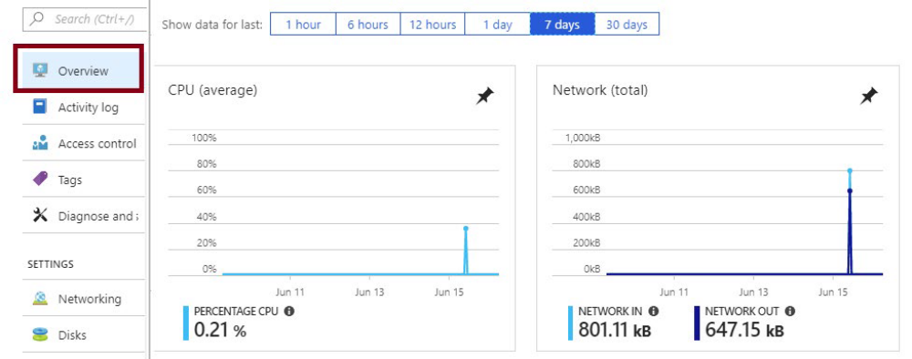
The Monitoring section provides access to Metrics, Diagnostic settings, Advisor recommendations, and Diagram. Azure Monitoring provides the metrics and they are specific to virtual machines.
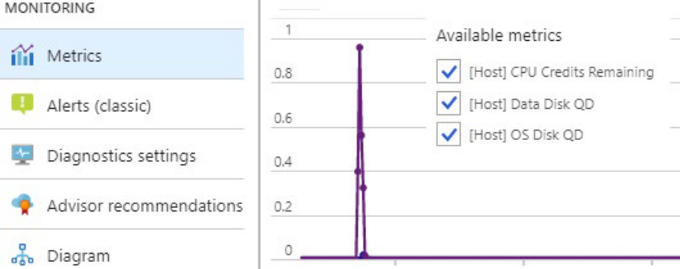

✔️Take a few minutes to navigate the Overview page and the Monitoring section to see what is available for your virtual machine.
For more information, you can see:
How to monitor virtual machines in Azure - https://docs.microsoft.com/en-us/azure/virtual-machines/windows/monitor
Diagnostic settings
The Virtual Machine’s Diagnostic setting blade is different for Windows and Linux machines. On Windows machines you have access to Performance counters, Logs, Crash dumps, Sinks, and Agent. Sinks in this context refers to sending your diagnostic data to other services, like Application Insights (additional charges may apply).

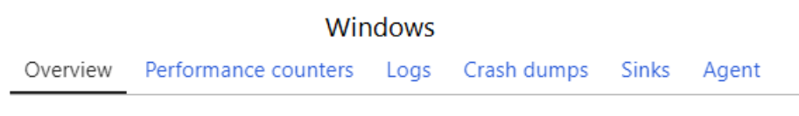

On Linux machines your choices are Metrics, Syslog, and Agent. You will need to have version 3.0 or higher of the Linux Diagnostic extension installed in order to edit your diagnostic settings through the portal.
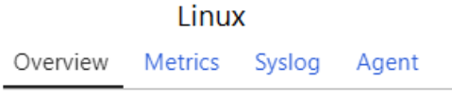
✔️The diagnostics settings can't be updated when the virtual machine isn't running.
For more information, you can see:
Overview of metrics in Microsoft Azure - https://docs.microsoft.com/en-us/azure/monitoring-and-diagnostics/monitoring-overview-metrics
Advisor Recommendations
Advisor is a personalized cloud consultant that helps you follow best practices to optimize your Azure deployments. It analyzes your resource configuration and usage telemetry and then recommends solutions that can help you improve the cost effectiveness, performance, high availability, and security of your Azure resources.
With Advisor, you can:
- Get proactive, actionable, and personalized best practices recommendations.
- Improve the performance, security, and high availability of your resources, as you identify opportunities to reduce your overall Azure spend.
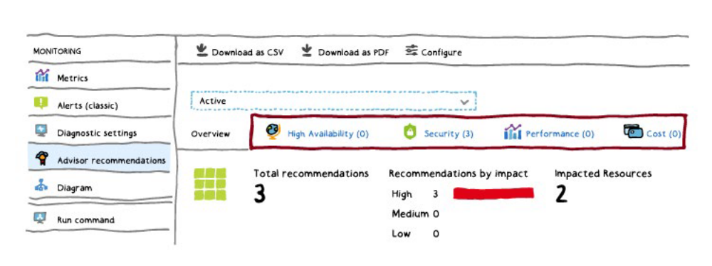

Get recommendations with proposed actions inline.
- High Availability recommendations3
- 3 https://docs.microsoft.com/en-us/azure/advisor/advisor-high-availability-recommendations helps you ensure and improve the continuity of your business-critical applications.
- Security recommendations4
- 4 https://docs.microsoft.com/en-us/azure/advisor/advisor-security-recommendations to detect threats and vulnerabilities that might lead to security breaches.
- Performance recommendations5
- 5 https://docs.microsoft.com/en-us/azure/advisor/advisor-performance-recommendations to improve the speed of your applications.
- Cost recommendations6
- 6 https://docs.microsoft.com/en-us/azure/advisor/advisor-cost-recommendations to optimize and reduce your overall Azure spending.
- Operatational excellence7
- 7 https://docs.microsoft.com/en-us/azure/advisor/advisor-operational-excellence-recommendationsto help with process and workflow efficiency, resource manageability and deployment best practices.

For more information, you can see:
Introduction to Azure Advisor - https://docs.microsoft.com/en-us/azure/advisor/advisor-overview
‍Online

